Lindsay D. Walker
Natural Disasters
ePortfolio #3 assignment
The Environmental Issue of Waste
People are throwing too many things away. Landfills are full of rotting organic matter, household cleaning chemicals, items that can take over a million years to decompose. Such as Styrofoam and electronics.
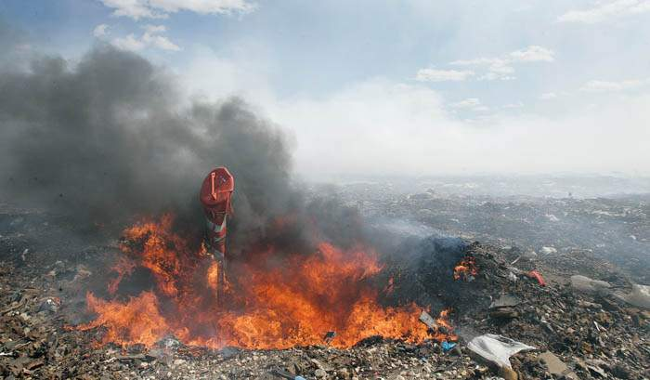
Gases are being produced that can be toxic and start dangerous fires that must be put out with more chemicals. All of these toxic gases that are being produced in the landfills and are reaching our atmosphere, which significantly impact the air quality. Chemicals can be rained on in the landfill, like electronics that were not recycled, and can drain into local water supplies. A lot of dead animals are being found in the landfills. They come in looking for food and eat things with household chemicals, or are overwhelmed by the gases being admitted.
Landfill waste is occurring everywhere! Even in Salt Lake City, UT. “In 2001 Americans threw out about 570 billion pounds of municipal solid waste. Compared to other nations, the USA has a record of generating waste at an alarming rate. Home to only 4% of the global population, we are responsible for more than 30% of the planets total waste generation. Each American discards and average of more than 1,650 pounds of garbage every year, approximately 4.6 pounds per person each day, nearly double the 1960 average of 2.7 pounds per day’. (Toxic Action Center)
In a KSL news report by Amanda Butterfield titled “Salt Lake Valley Landfills Filling up fast. She stated to the public that, ‘each day, 1,500 tons of trash is dumped at the Salt Lake Valley Landfill. Salt Lake County owns 550 acres of land for all this rubbish, but in less than 50 years it will be all used up’. She also said ‘If we just recycled our plastic and paper, we would have 50 percent more space’.
People are not taking the time to separate their garbage into recycle. Because of fast food and convenience, there are great amount of containers, bag, bottles, and other items that we can grab on the go. We have not be educated enough on where we can place our unwanted items, so that they can be reused and not be buried underground. People need to understand that food items with decompose very quickly and safely, where as our old broken umbrellas or bedframes will take millions of years to decompose.
Recycling bins and containers are becoming much more readily available. Companies are finding ways to use garbage as fuel and energy to run their cars, businesses, and machines.
We can use the reusable bags that stores offer instead of plastic bags. We could properly dispose of our unwanted computers, phones and other electronic places to companies that can properly recycle the pieces and reuse the items to fix other things.
‘We could create a market for recycled materials. Jobs can be created for sorting materials and creating goods to re-enter the economy. We could also require companies to produce products with minimum packaging and phase out toxic ingredients in favor of safer alternatives’. (Toxic Action Center)

Works Cited
Butterfield, Amanda. "Salt Lake Valley Landfills Filling up Fast | KSL.com." Salt Lake Valley Landfills Filling up Fast | KSL.com. 29 Sept. 2010. Web. 10 Oct. 2014.

Fire debris, Janesville, WI. Personal photograph by Bill Olmsted. 2012.

"Fire Prevention Week: October 5-11." U.S. Fire Administration. Web. 10 Oct. 2014.

"The Problems with Waste." Communities In Action. Web. 10 Oct. 2014.

Trans-Jordan. Trans-Jordan Landfill. Web. 10 Oct. 2014.

Toxic Action Center. Web. 10 Oct. 2014.

