HLAC-1013-004-Sp15
Group Presentation Assignment
March 31, 2015
Lindsay: (Legs)
The exercises that we are going to do focus mainly on strengthening and toning our leg and Gluteus muscles such as: 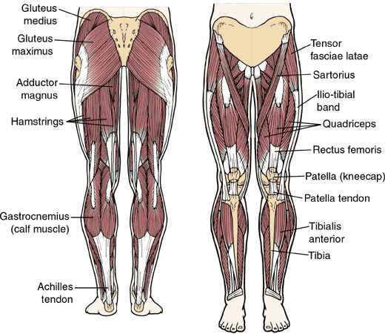

- Megan E.
- Things to Know about How to Properly Squat:
- -Stand erect with your feet approximately one shoulder width apart.
- From there, you can widen or narrow your stance depending on which muscles you are targeting -- a wider stance works the hamstrings and glutes, while a narrower stance works the quads.
- Point your toes slightly outwards, as this helps to stabilize your stance.
- Keep your arms extended in front of you.

Michael:
- -Push your hips back, slowly bending your knees to a 90-degree angle.
- Rather than squatting straight down, you want to hinge your hips so that your butt moves backwards, almost as if you were sitting in an invisible chair.
- Keep bending until your hamstrings are parallel with the floor. Your knees shouldn't extend beyond the tips of your toes, unless you are very tall.
- Your body weight should be concentrated on your heels rather than on your toes. This will allow you to squat deeper.
- Megan L:
- -Keep your back straight and eyes looking ahead.
- It is very important to keep your back straight while squatting; otherwise you could put unnecessary pressure on the spine, which could lead to a pulled muscle or a herniated disc.
- Keeping your chest up and your eyes pointing straight ahead will help you to keep your back straight as you squat. Also try to keep your stomach muscles engaged as you perform the exercise.
- Exercises to Be Performed in Class

Side Squats: 3 sets of eight
- (Eric and Megan L) Easy: Begin standing with feet together. Squat halfway down to the right as far as you can manage. Bring your right leg towards your left, returning to your standing position. Alternate your steps each time.
- (Megan E) Medium: Squat as low as you can
- (Michael and Lindsay) Hard: Hold your bar with weights on your shoulders

- Step-up with Knee Rise: 2 sets of 16
- (Eric and Megan L) Easy: Stand facing your bench of an appropriate height with your feet together. This will be your starting position. Begin the movement by stepping up, putting your left foot on the top of the bench- Extend through the hip and knee of your front leg to stand up on the box. As you stand on the box with your left leg to stand up on the box with your left leg, flex your right knee and hip, bringing your knee as high as you can. Reverse this motion to step down off the box, and then repeat the sequence on the opposite leg.
- (Michael and Lindsay) Medium: Add a squat when both feet are on the floor before you alternate your next foot.
- (Megan E) Hard: hold weights in your hands. Put weights to you sides and squat, then step up on the bench with your hand held straight out in front, palm down opposite of the knee being risen.
- Eric:
- Things to Know About How to Properly Lunge
- -As you step forward, lower your hips and bend your knees until they both form 90-degree angles.
- -Your front knee should not extend over your toes and your back knee should not touch the ground.

- Dumbbell Rear Lunge: 2 sets of 12
- (Michael) Easy: Stand with your torso upright holding two heavy dumbbells in your hands by your sides. This will be the starting position: Step backward with your right leg around two feet or so from the left foot and lower your upper body down while keeping the torso upright and maintaining balance. Inhale as you go down. Remember to not allow your knee to go forward beyond your toes as you come down, as this will put undue stress on the knee joint. Make sure that you keep your front shin perpendicular to the ground. Keep your torso upright during the lunge. Push up and go back to the starting position, and repeat with the opposite leg.
- (Eric and Megan L) Medium: push up and go back to the starting position and as you exhale lift your right knee keeping your back straight. Use the ball of your feet in order to accentuate the quadriceps. To focus on the glutes, press with your heels.
- (Megan E) Medium-Hard: Hold only one weight to your side as you step down into your lunge and then stand back up. Switch the weight to your other hand and step down into you lunge with your other leg and repeat.
- (Lindsay) Hard: only hold one weight in the hand of the same leg that is stepping back. When you are down in your lunge, pass your weight under your knee to your other hand waiting on the other side of your body.

References
"Bodybuilding.com - How To Squat: Proper Techniques For A Perfect Squat." Bodybuilding.com. 1 May 2003. Web. 26 Mar. 2015. <http://www.bodybuilding.com/fun/cyberpump1.htm>.

HENKIN, JOSH. "Revenge of the Lunge!" RKC School of Strength RSS. Dragon Door Publications, 14 Aug. 2013. Web. 26 Mar. 2015. <http://rkcblog.dragondoor.com/revenge-of-the-lunge-henkin/>.

"How to Do Squats and Lunges." WikiHow. Web. 26 Mar. 2015. <http://www.wikihow.com/Do-Squats-and-Lunges>.

Web. 26 Mar. 2015. <http://www.workout-routines-that-work.com/images/leg-workout-routine-leg-anatomy.jpg>.

